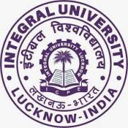

**Department of Biosciences**

**Integral University, Lucknow**

***DEPARTMENT OF BIOSCIENCES ORIENTATION PROGRAM 2023-24***

Integral University with the objective to welcoming new students to the university, has conducted the orientation program successfully for the session **2023-2024**. The program commenced with the centralized orientation program on **24th August 2023** at the **Convocation Main Lawn** from **9:00 AM** **onwards** in the presence of **Hon’ble Chancellor Prof. S.W Akhtar, Hon’ble Pro-chancellor Prof. Syed Nadeem Akhtar, Hon’ble Vice-Chancellor Prof. Javed Musarrat and other dignitaries**. They addressed the newly admitted students with their words of wisdom and welcomed all of them with great zeal and enthusiasm.

The three days are dedicated to the departmental orientation program which was held in the Departmental Seminar Hall, Academic Block B, Faculty of Science, Department of Biosciences from **24th August** to **26th August 2023,** respectively.

The **first day of the departmental orientation program**was held on **24th August** at **2:00 PM**and started with the welcome address by **Dr. Amita Dubey,** she welcomed the Head of Department,  **Dr. Snober S. Mir**, faculty members, and students with their kind words followed by the introduction of the faculty members and self introduction of new students. The day continued with a discussion about UG/PG ordinances, addressed by Chairperson DQAC and PG coordinator **Dr. Mohd. Ashfaque,** and UG coordinator, **Dr. Swati Sharma**. The program concluded with a vote of thanks and briefing about next day program by **Dr. Taiba Saeed.**

The **second day of the orientation** program witnessed various knowledge-gaining activities organized by the Department of Biosciences on **25th August, 2023**. The second day of the program started with a welcome note by **Dr. Durdana Yasin** and a briefing about the day’s program. The program was continued with a TedEx video coordinated by **Dr. Swati Sharma,** andaddressed by **Dr. Arshi Siddiqui** coordinator, Departmental Website Committee (DWC) about the departmental website, Integral Learning Initiative (ILI), and student mobile applications for various academic purposes. In her presentation, Dr. Siddiqui detailed the functionalities and benefits of these systems. The Learning Management System, ILI Zone, offers advanced tools for course management, content sharing, accessing the notes, uploading the assignment and student engagement thus enhancing the teaching methods. The logging procedure, way to access these two portals were also briefed to students. Additionally, the features of SMIS and IU App such as attendance details, fees details and other features were detailed to newly admitted students. Dr. Siddiqui's informative session regarding the details and content available on the departmental website page has equipped our newly admitted student and department with valuable insights to optimize our digital infrastructure for a more effective learning experience. The session continued with the final year UG/PG program student interactions which were coordinated by **Dr. Mohammad Ikram Ansari.** The program concluded with a vote of thanks by **Dr. Mohd Khubaib.** After the tea break the day commenced with the visit of Campus/Department lab and classrooms/Central Library/Sports/Music Society/Alumni Office with **Ms. Poonam Sharma, Mr. Soban A Faridi, Dr. Farina Mujeeb, Dr. Durdana Yasin, Dr. Sangeeta Singh, Dr. Mohsin Vahid Khan, Dr. Reena Vishvakarma, Dr. Arsheid Manzoor**

The **third day of the orientation** program organized by the department of biosciences on **26th August, 2023**. The third day of the program started with a welcome note by **Dr. Swati Sharma** with a briefing about the day’s program. **Dr. Muthukumar M., Senior Scientist**, ICAR CISH (Central Institute for Subtropical Horticulture), Lucknow, delivered an insightful lecture on the evolving biotechnological research landscape and the role of recent technologies in the industry. He shared his experiences and provided valuable insights into career opportunities for graduates and masters students. The Departmental Placement coordinator **Dr. Irfan Ahmad Ansari** told them about placement and progression. The Placement Coordinator discussed the department's efforts to facilitate internships and job placements for students. He emphasized the importance of building a strong foundation for future careers. Followed by alumni shared their career journeys, offering guidance and motivation to current students.

The two days orientation program was well-organized by **Dr. Mohd. Ashfaque** and **Dr. Arshi Siddiqui** along with the faculty members and student representatives of the department.

**Glimpses of the event and minute-to-minute schedules.**

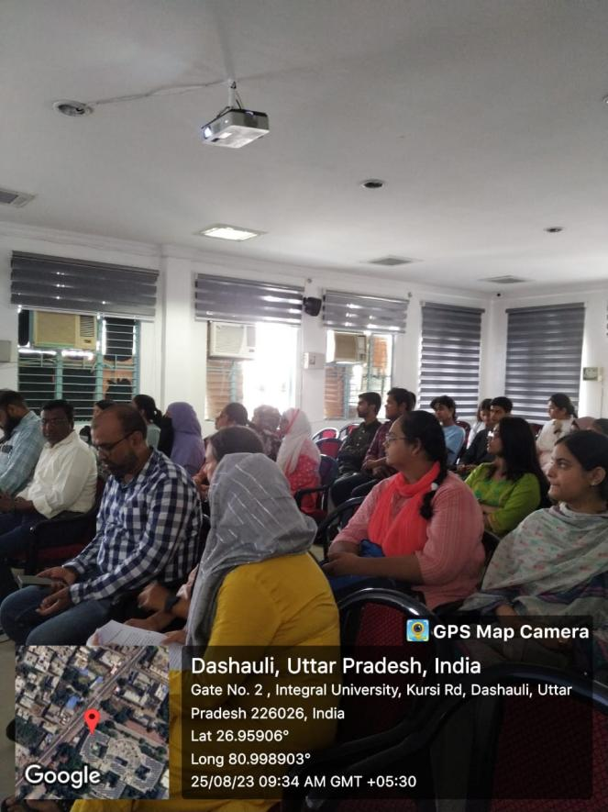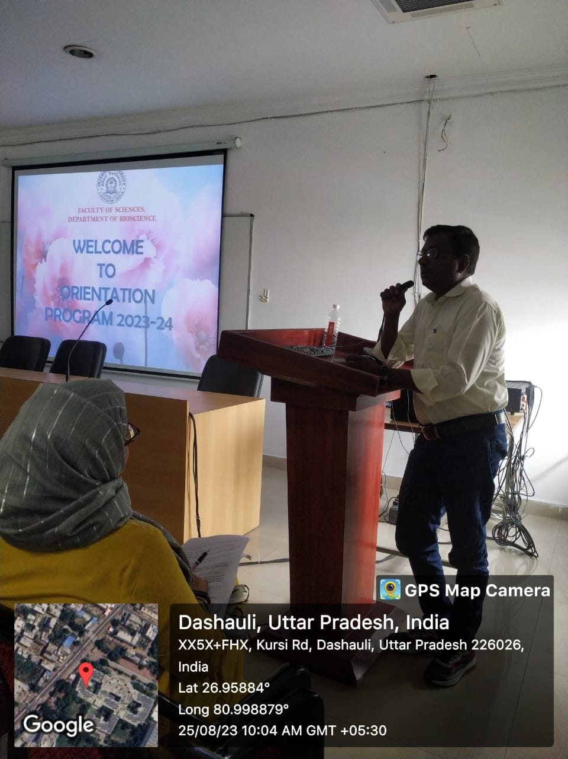

Self introduction of faculty

Glimpse of first day program

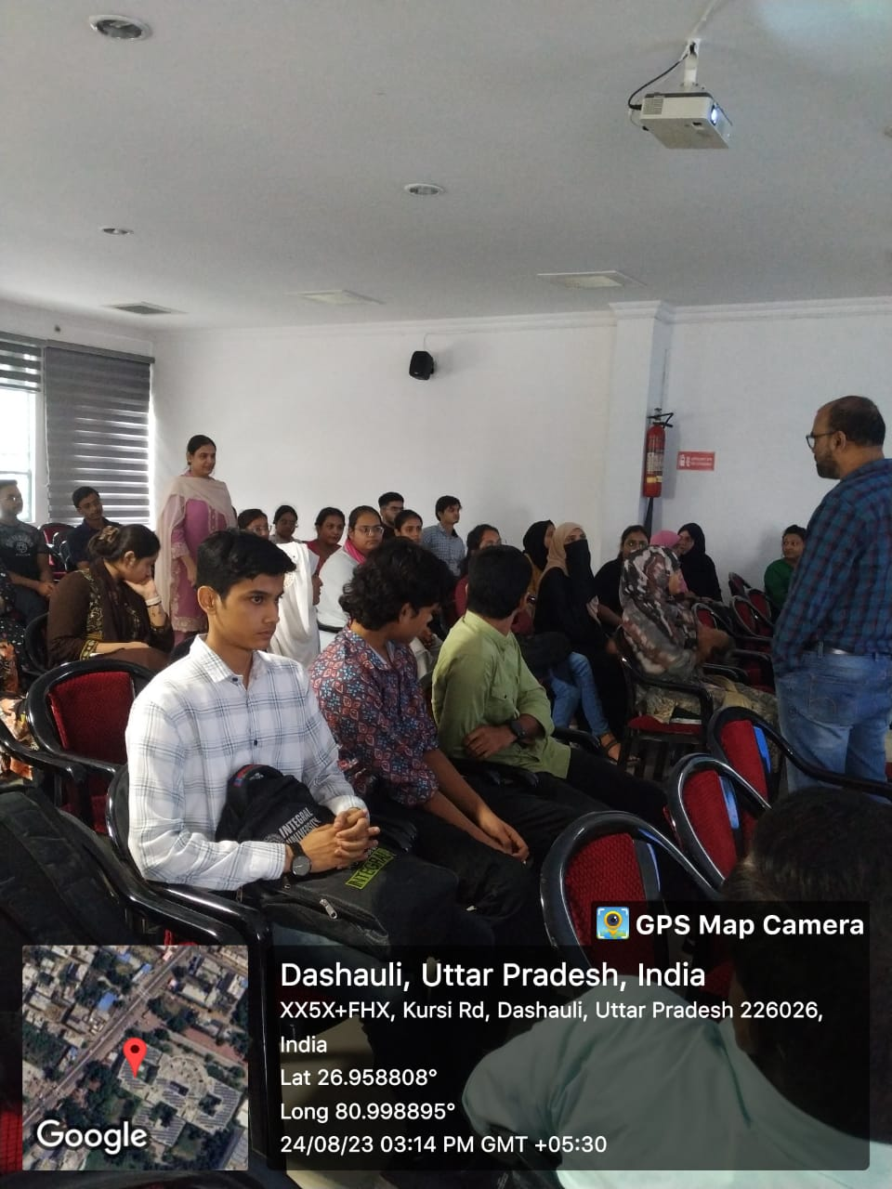 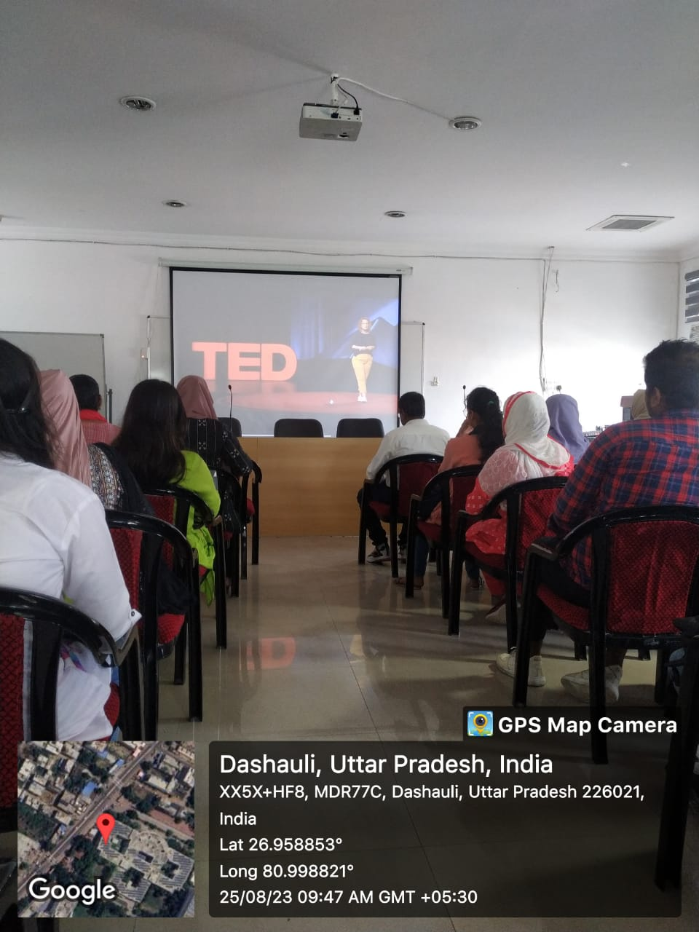

TedEx Videos coordinated by Dr. Swati Sharma

Self introduction of new students

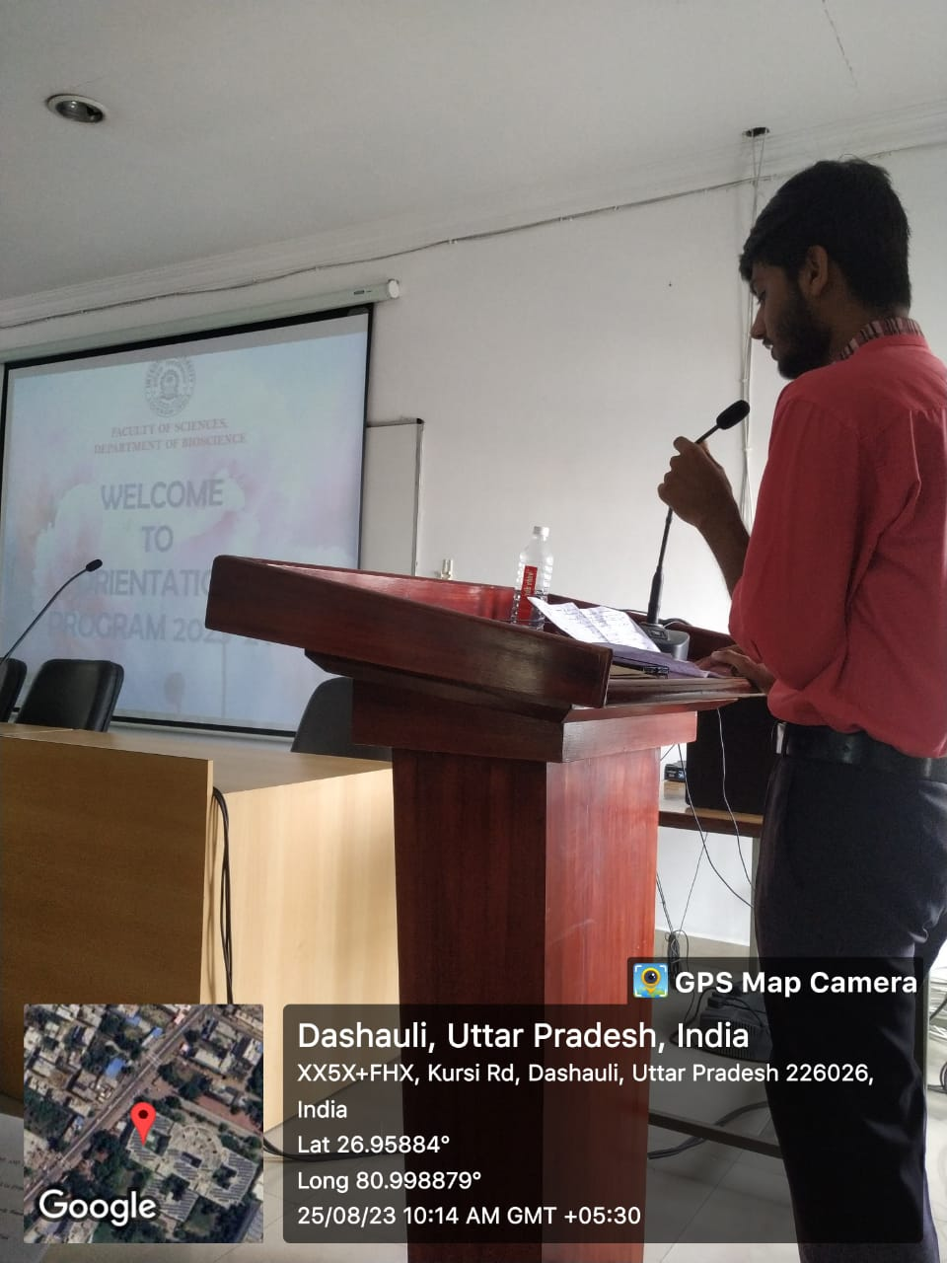 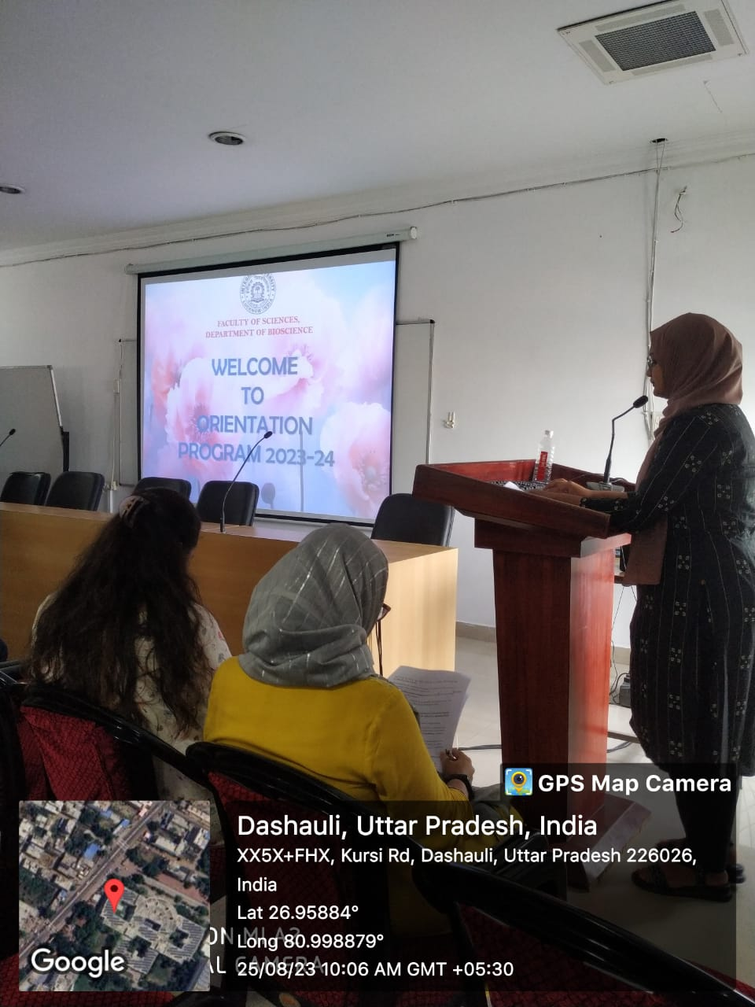

Interaction with students of final year of UG and PG Programs to talk about life in University

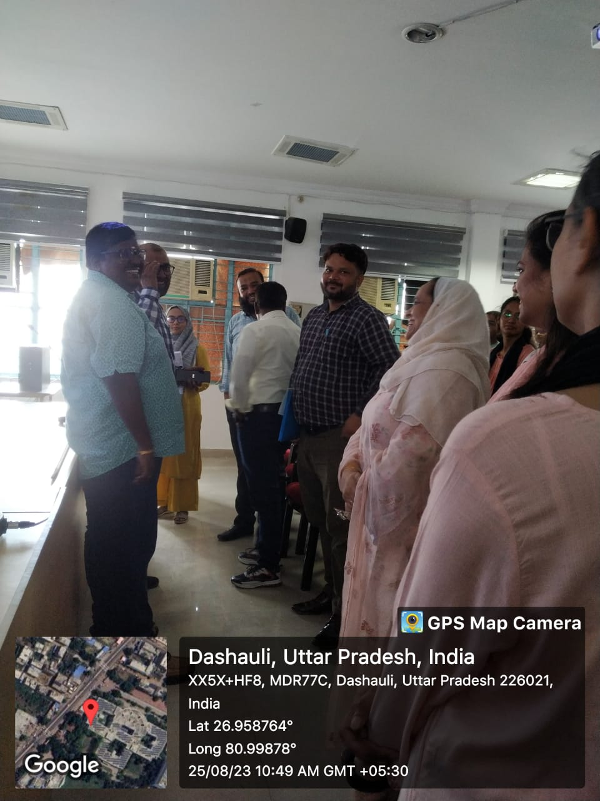

Interaction with guest speaker

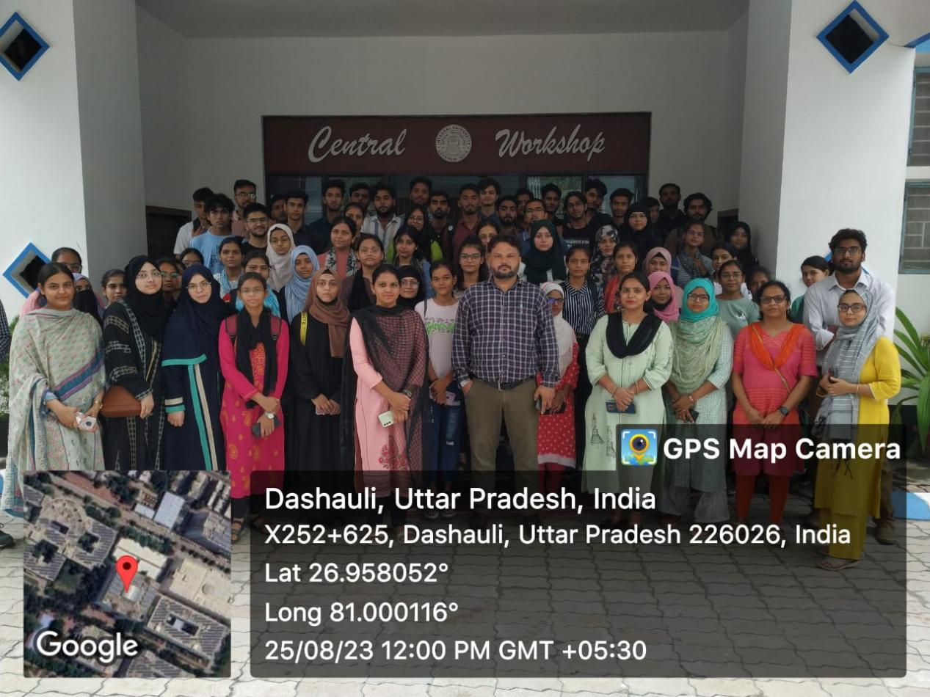

Visit of central Library

Interaction with guest speaker

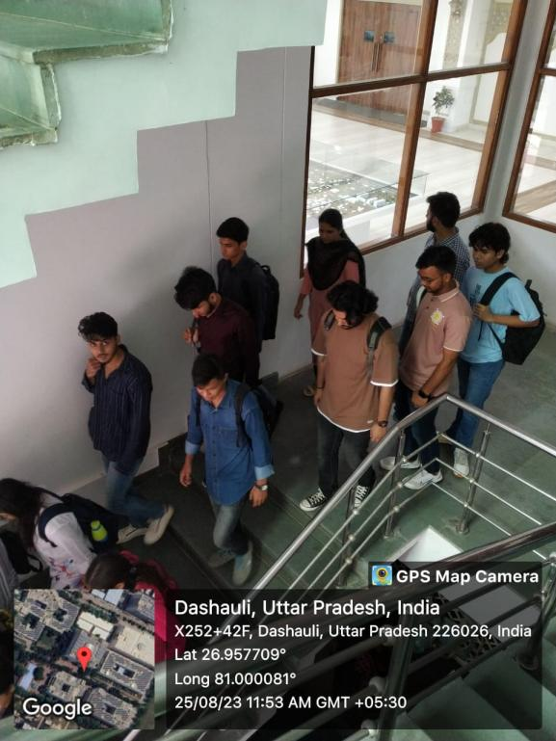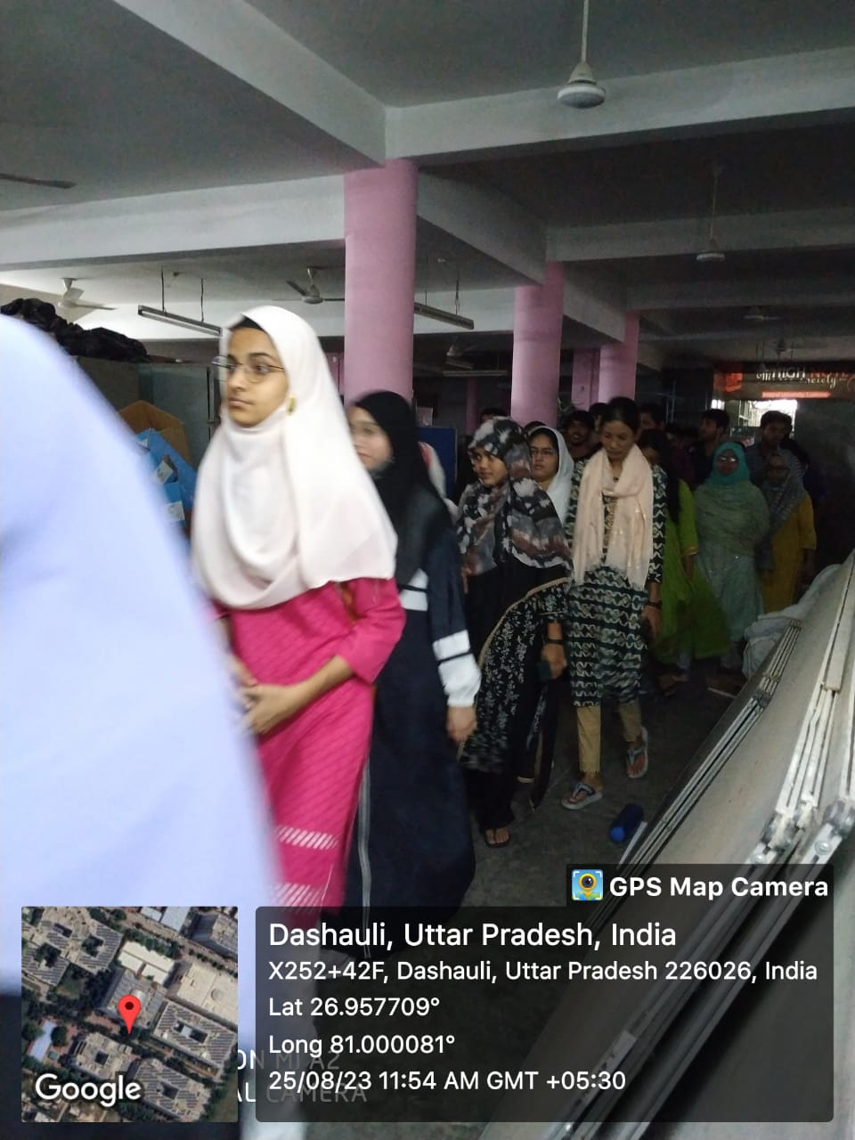

Students during Campus visit

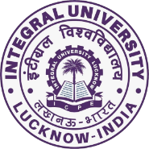

**DEPARTMENT OF BIOSCIENCES**

**FACULTY OF SCIENCE**

**INTEGRAL UNIVERSITY, LUCKNOW**

**Schedule for Orientation Programme 2023-24**

**Overall Coordinators: Dr. Mohd Ashfaque & Dr. Arshi Siddiqui**

**Day 1(24th August, 2023)**

**Venue: Departmental Auditorium**

**Coordinators Day 1: Dr. Farina Mujeeb & Dr. Amita Dubey**

|  |  |
| --- | --- |
| 02:00 – 02:05 PM | Anchoring by **Dr. Amita Dubey** |
| 02:05 – 02:25 PM | Address by Head, **Prof. (Dr.) Snober S. Mir** |
| 02:25 – 02:50 PM | Self-introduction of Faculty members & Staff (Profile should include name, academic background, expertise, achievements, subjects taught, R&D, research projects, publications/patents) |
| 02:50 – 03.20 PM | Self-introduction of Students |
| 03:20 – 03.30 PM | Address by **Dr. Swati Sharma, UG coordinator** |
| 03:30 – 03.40 PM | Address by **Dr. Mohd. Ashfaque**, **PG coordinator** |
| 03:40 – 03.45 PM | Thanks and briefing about next day’s programme by **Dr. Taiba Saeed** |

**Refreshment Committee:** Dr. Mohd. Khubaib, Dr. Mohsin Vahid Khan , Dr.Shahida Hamid, Mr. Abdullah Hassan, Ms. Smita Rai.

**Day 2 (25th August, 2023)**

**Venue: Departmental Auditorium**

**Coordinators Day 2: Dr. Jahanarah Khatoon and Dr. Mohd. Ikram Ansari**

|  |  |
| --- | --- |
|  | Anchoring by **Dr. Sabihur Rahman & Dr. Imran Husain** |
| 09:30 – 09:40 AM | Address by Departmental Website Coordinators (DWC): **Dr. Arshi Siddiqui & Ms. Poonam Sharma** |
| 09:40 – 09:50 AM | TedEx Videos coordinated by **Dr. Swati Sharma &** **Dr. Khwaja Osama** |
| 09:50 – 10:20 AM | Expert Lecture |
| 10:20 – 10:40 AM | Interaction with students of final year of UG and PG Programs to talk about life in university: Coordinated by **Dr. Ashish & Dr. Mohammad Ikram Ansari** |
| 10:40 – 10:45 AM | Vote of Thanks by **Dr. Mohd Khubaib** |
|  | Break |
| 1:45 PM onwards | Visit of Campus/Department lab and classrooms/Central Library/Sports/Music Society/Alumni Office  **Ms. Poonam Sharma, Mr. Soban A Faridi, Dr. Farina Mujeeb, Dr. Durdana Yasin, Dr. Sangeeta Singh, Dr. Mohsin Vahid Khan, Dr. Reena Vishvakarma, Dr. Arsheid Manzoor** |

**Day 3(26th August, 2023)**

**Venue: Departmental Auditorium**

**Coordinators Day 3: Dr. Swati Sharma and Dr. Sangeeta Singh**

|  |  |
| --- | --- |
|  | Welcome by **Dr. Swati Sharma & Ms. Poonam Sharma** and briefing about the day’s programme |
| 10:00 – 10:30 AM | Expert Lecture, **Dr. Muthukumar M.**, Senior Scientist, ICAR CISH |
| 10:30 – 10:50 AM | Address by Department Placement Coordinators (DPC): **Dr. Irfan A Ansari & Mr. Soban A Faridi** |
| 10:50 – 11:30 AM | Address by Alumni coordinated by **Dr. Salman Khan & Mr. Soban A Faridi** |